**SHANKARACHARYA**

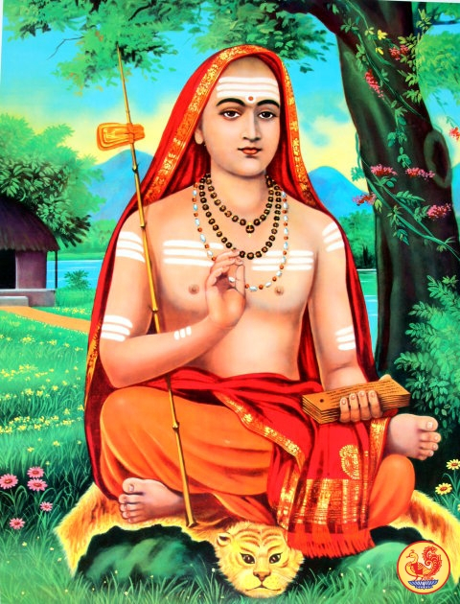

Adi Shankara was an Indian philosopher and theologian who expounded the doctrine of Advaita Vedanta. He renounced the worldly pleasures at a very young age. Shankaracharya amalgamated the ideologies of ancient ‘Advaita Vedanta’ and also explained the basic ideas of Upanishads. He advocated the oldest concept of Hinduism which explains the unification of the soul (atman) with the Supreme Soul (Nirguna Brahman).

Though he is best known for popularizing ‘Advaita Vedanta’, one of Shankaracharya’s most important works is his efforts to synthesize the six sub-sects, known as ‘Shanmata.’ ‘Shanmata’, which literally translates to ‘six religions,’ is the worship of six supreme deities. Shankaracharya explained the existence of one Supreme Being (Brahman) and that the six supreme deities are part of one divine power. He also founded ‘Dashanami Sampradaya,’ which talks about leading a monastic life.

While Shankaracharya was a firm believer in ancient Hinduism, he condemned the ‘Mimamsa school of Hinduism’ which was purely based on ritual practices. Throughout the course of his journey, Shankaracharya discussed his ideas with various other philosophers and fine-tuned his own teachings from time to time. Shankaracharya founded four monasteries (mathas) that continue to spread his teachings.

**Birth**

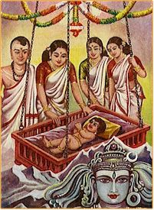Shankara, as he was known before becoming a great teacher, was born into a poor Brahmin family at Kaladi, present day Kerala, India. His parents, Sivaguru and Aryamba, offered their prayers to Lord Shiva, requesting the deity to bless them with a child.

Their prayers were soon answered in the form of a baby boy. A few theories suggest that Aryamba had a dream in which Lord Shiva himself promised her that he would be taking birth as her child. Hence, many consider Shankara as a reincarnation of Shiva. Shankara was educated by his mother as he lost his father when he was just seven. Aryamba played a key role in teaching Vedas and Upanishads to a young Shankara.

There is a lot of confusion regarding the birth-date of Shankara as different sources have proposed several different dates. The most accepted birth-date places him as a scholar from the first half of the 8th century CE.

**Life**

Throughout the course of his early life, Shankara astounded many with his knowledge intelligence. He started writing his own analysis of the Upanishads, Brahma Sutras and the Bhagavad Gita at a young age. Right from his childhood, he was keen on becoming a monk. Though his idea of becoming a monk was opposed by his mother, Shankara knew exactly what he had to do. Once he accompanied his mother to a nearby river and took a plunge into the river.

Suddenly, a crocodile appeared from beneath the river and caught hold of his leg. Shankara then cried out to his mother, saying that a crocodile was pulling him into the river. When his mother felt helpless, Shankara urged her to allow him to die as a monk. As soon as Aryamba gave her consent, the crocodile spared Shankara’s life and went back into the river.

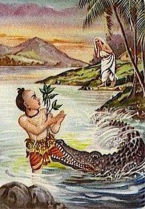

Shankara was miraculously unharmed and went on to become a monk as his mother had already given him the permission to do so. He then went in search of a guru and according to a few ancient scripts, a young Shankara walked at least 2000 kilometers before meeting Govinda Bhagavatpada. Under Govinda Bhagavatpada’s guidance, Shankara studied ‘Gaudapadiya Karika’, ‘Brahmasutra’, Vedas, and Upanishads. To his teacher’s amazement, Shankara was able to master almost all the ancient scripts in a short time. He even started writing commentaries on major religious scripts. Once he had a clear understanding of the ancient Hindu scripts, he started traveling across India, propagating ‘Advaita Vedanta’ and ‘Dashanami Sampradaya.’

During the course of his journey, Shankara’s teachings were challenged by many philosophers and thinkers. He was even involved in a number of debates pertaining to Hinduism and its beliefs, but Shankara managed to astound all his doubters with his intelligence and clarity. He then went about propagating his ideas and was soon accepted as a guru by many.

**Disciples**

Shankara came to be known as Shankaracharya among his disciples. Though he had several disciples, four of them would go on to achieve great heights to be later considered as Shankaracharya’s main disciples. They were also entrusted with the responsibility of heading the four monasteries (mathas) founded by Shankaracharya. Here are Shankara’s four disciples:

* **Padmapada** – Padmapada was born Sanandana and later went on to become one of the most ardent followers of Adi Shankaracharya. According to the ancient texts, Sanandana was once drying his master’s clothes on the banks of Ganges. When Shankaracharya asked for his clothes from the other side of the river, Sanandana started crossing the mighty Ganges, holding his master’s clothes close to his chest. To the amazement of the onlookers, many lotuses emerged from the river and supported Sanandana’s weight, saving him from drowning. After crossing the river, Sanandana handed the clothes over to Shankaracharya who then bestowed him with the name ‘Padmapada’ which literally means ‘the one with lotus feet.’ Padmapada founded ‘Thekke Matham’, a monastery in Thrissur, Kerala.
* **Totakacharya** – Totakacharya was born Giri and became a disciple of Adi Shankaracharya at a very young age. Giri was considered a fool by Shankaracharya’s other disciples. He was hardly interested in learning but was completely devoted to his master. Once, when Shankaracharya held on to his teachings as he waited patiently for Giri to join the rest of his disciples, Padmapada urged his master to go ahead as he thought teaching anything to Giri was a sheer waste of time. Shankaracharya then decided to reward Giri for his devotion and mentally transferred all his knowledge to Giri. Giri then went on to compose a poem named ‘Totakashtakam’ and came to be known as Totakacharya. Totakacharya founded a monastery named ‘Vadakke Modam’ in Thrissur.
* **Hasta Malaka** – When Shankaracharya visited a village near Kollur (Karnataka), a Brahmin named Prabhakara came forward, along with his son, to meet him. Prabhakara told him that his son is a lunatic and that he is good for nothing. Shankaracharya looked at his son and asked him a few questions. The boy then replied in verses which explained Advaita philosophy. Amazed by his knowledge, Shankaracharya named him Hasta Malaka and accepted him as his disciple. Hasta Malaka founded ‘Idayil Matham’ in Thrissur.
* **Sureshvara** – Sureshvara was born Mandana Misra and was leading the life of an average householder. Misra was a brilliant exponent of ‘Karma Mimamsa’ and was considered Shankaracharya’s contemporary. When Shankaracharya finally met the famous Mandana Misra, he challenged him to a debate. After a furious debate which went on for months, Mandana Misra finally accepted defeat and agreed to become Shankaracharya’s disciple. He came to be known as Sureshvara and founded 'Naduvil Matham' in Thrissur.

**Death**

At the age of 32, Adi Shankaracharya retired to the Himalayas and is believed to have entered a cave near Kedarnath. He was never seen again and the cave that he entered is considered as his final resting place.

**Works**

Adi Shankaracharya is renowned for his spectacular commentaries on ancient texts. His review of ‘Brahma Sutra’ is known as ‘Brahmasutrabhasya’, and it is the oldest surviving commentary on ‘Brahma Sutra’. It is also considered as his best work. He also wrote commentaries on Bhagavad Gita, and the ten principal Upanishads. Adi Shankaracharya is also well-known for his ‘stotras’ (poems). He composed many poems, praising gods and goddesses. The ones dedicated to Krishna and Shiva are considered most important among his ‘stotras’. He also composed the famous ‘Upadesasahasri’ which literally translates to ‘a thousand teachings.’ ‘Upadesasahasri’ is one of his most important philosophical works.

**Philosophy**

Adi Shankaracharya’s philosophy was simple and straightforward. He advocated the existence of the soul and the Supreme Soul. He believed that the Supreme Soul alone is real and unchanging while the soul is a changing entity and that it does not have absolute existence.

**Influence on Hinduism**

Adi Shankaracharya became a key figure in restoring belief in the Vedas and Upanishads. Smartism, a subsect of Hinduism, was formed based on his teachings. He is also credited with making Hindus understand the existence of one Supreme Being. He explained that all other deities are just different forms of the Supreme Being. The monasteries founded by Shankaracharya had a great influence in reforming Hinduism.

**Mathas**

Adi Shankaracharya founded four monasteries (mathas) - one each at the four cardinal points in India. Here are the four mathas founded by Shankara:

* **Sringeri Sharada Peetham** – This was the first monastery founded by Adi Shankaracharya. It is located at the southern part of India, along the banks of Tunga. Sureshvara was made the head of this matha as Shankaracharya moved on to establish other mathas. Sringeri Sharada Peetham advocates ‘Aham Brahmasmi’ (I am Brahman) and was formed on the basis of Yajur Veda.
* **Dvaraka Pitha** - Dvaraka Pitha is located in the western part of India. Hasta Malaka, who came to be known as Hastamalakacharya, was made the head of this matha. Dvaraka Pitha advocates ‘Tattvamasi’ (That thou art) and was formed on the basis of Sama Veda.
* **Jyotirmatha Peetham** – This monastery is located in the northern part of India. Totakacharya was made the head of this matha which advocates ‘Ayamatma Brahma’ (This Atman is Brahman). Jyotirmatha Peetham was formed on the basis of Atharva Veda.
* **Govardhana matha** - Govardhana matha is located at the eastern part of India. The matha is a part of the famous Jagannath temple. Padmapada was made the head of this monastery which advocates ‘Prajnanam Brahma’ (Consciousness is Brahman). It was formed on the basis of Rig Veda.

**Final rites of his mother**

Shankaracharya was somewhere in North India when he came to know of his mother’s impending death.  By using his Yogic powers, travelled through the air to reach her quickly. At her request, he granted her divine visions.

When he tried to arrange the cremation of his mother’s body, his relatives refused to help him on the grounds that as a Sannyasi he was not permitted to perform funeral rites. Normally this would have been a serious setback as a cremation involves rituals, which would require physical assistance by a few people. So Shankaracharya performed a miracle. He made a funeral pyre out of plantain stalks.

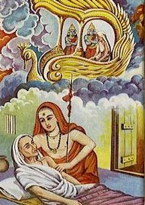

After placing the body on the pyre he took some water and after chanting a few mantras he sprinkled the water on the pyre. Immediately the pyre caught fire. Thus he was able to complete the funeral rites without help.